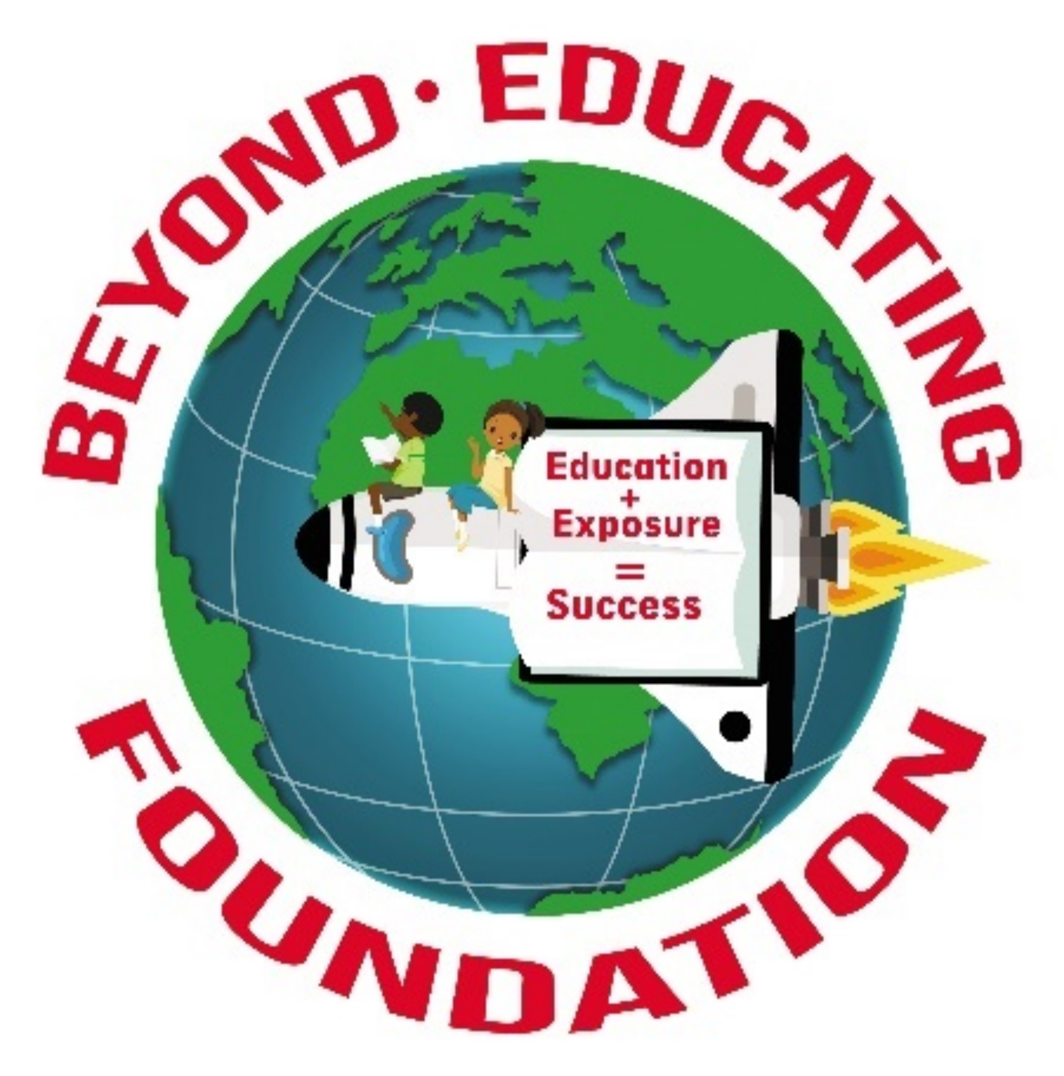
Beyond Educating Foundation
888-217-9797
cheers@beyondeducating.org
www.beyondeducating.org

Beyond Educating Foundation will host Developing A Growth Mindset Through S.T.E.A.M. Toy Giveaway on December 7, 2019 at Gaston Community Center from 10:00 am to 2:00pm.
Tentative Schedule
9:00-9:45 am Vendors Set-up/Volunteers Arrive/STEAM Stations Set-up
10:00-10:15 am Purpose of Event
10:15-10:30 am Words of Encouragement
10:30 am- 2:00 pm Membership Tables Open
10:30 am -1:30 pm STEAM Stations Open
10:30 am – 1:45 pm Vendors Open
1:45 - 2:00 pm Words of Appreciation
2:00 – 2:45 pm Break Down Booths, Tables and Clean-up
2:45 - 3:00 pm Lunch for Volunteers

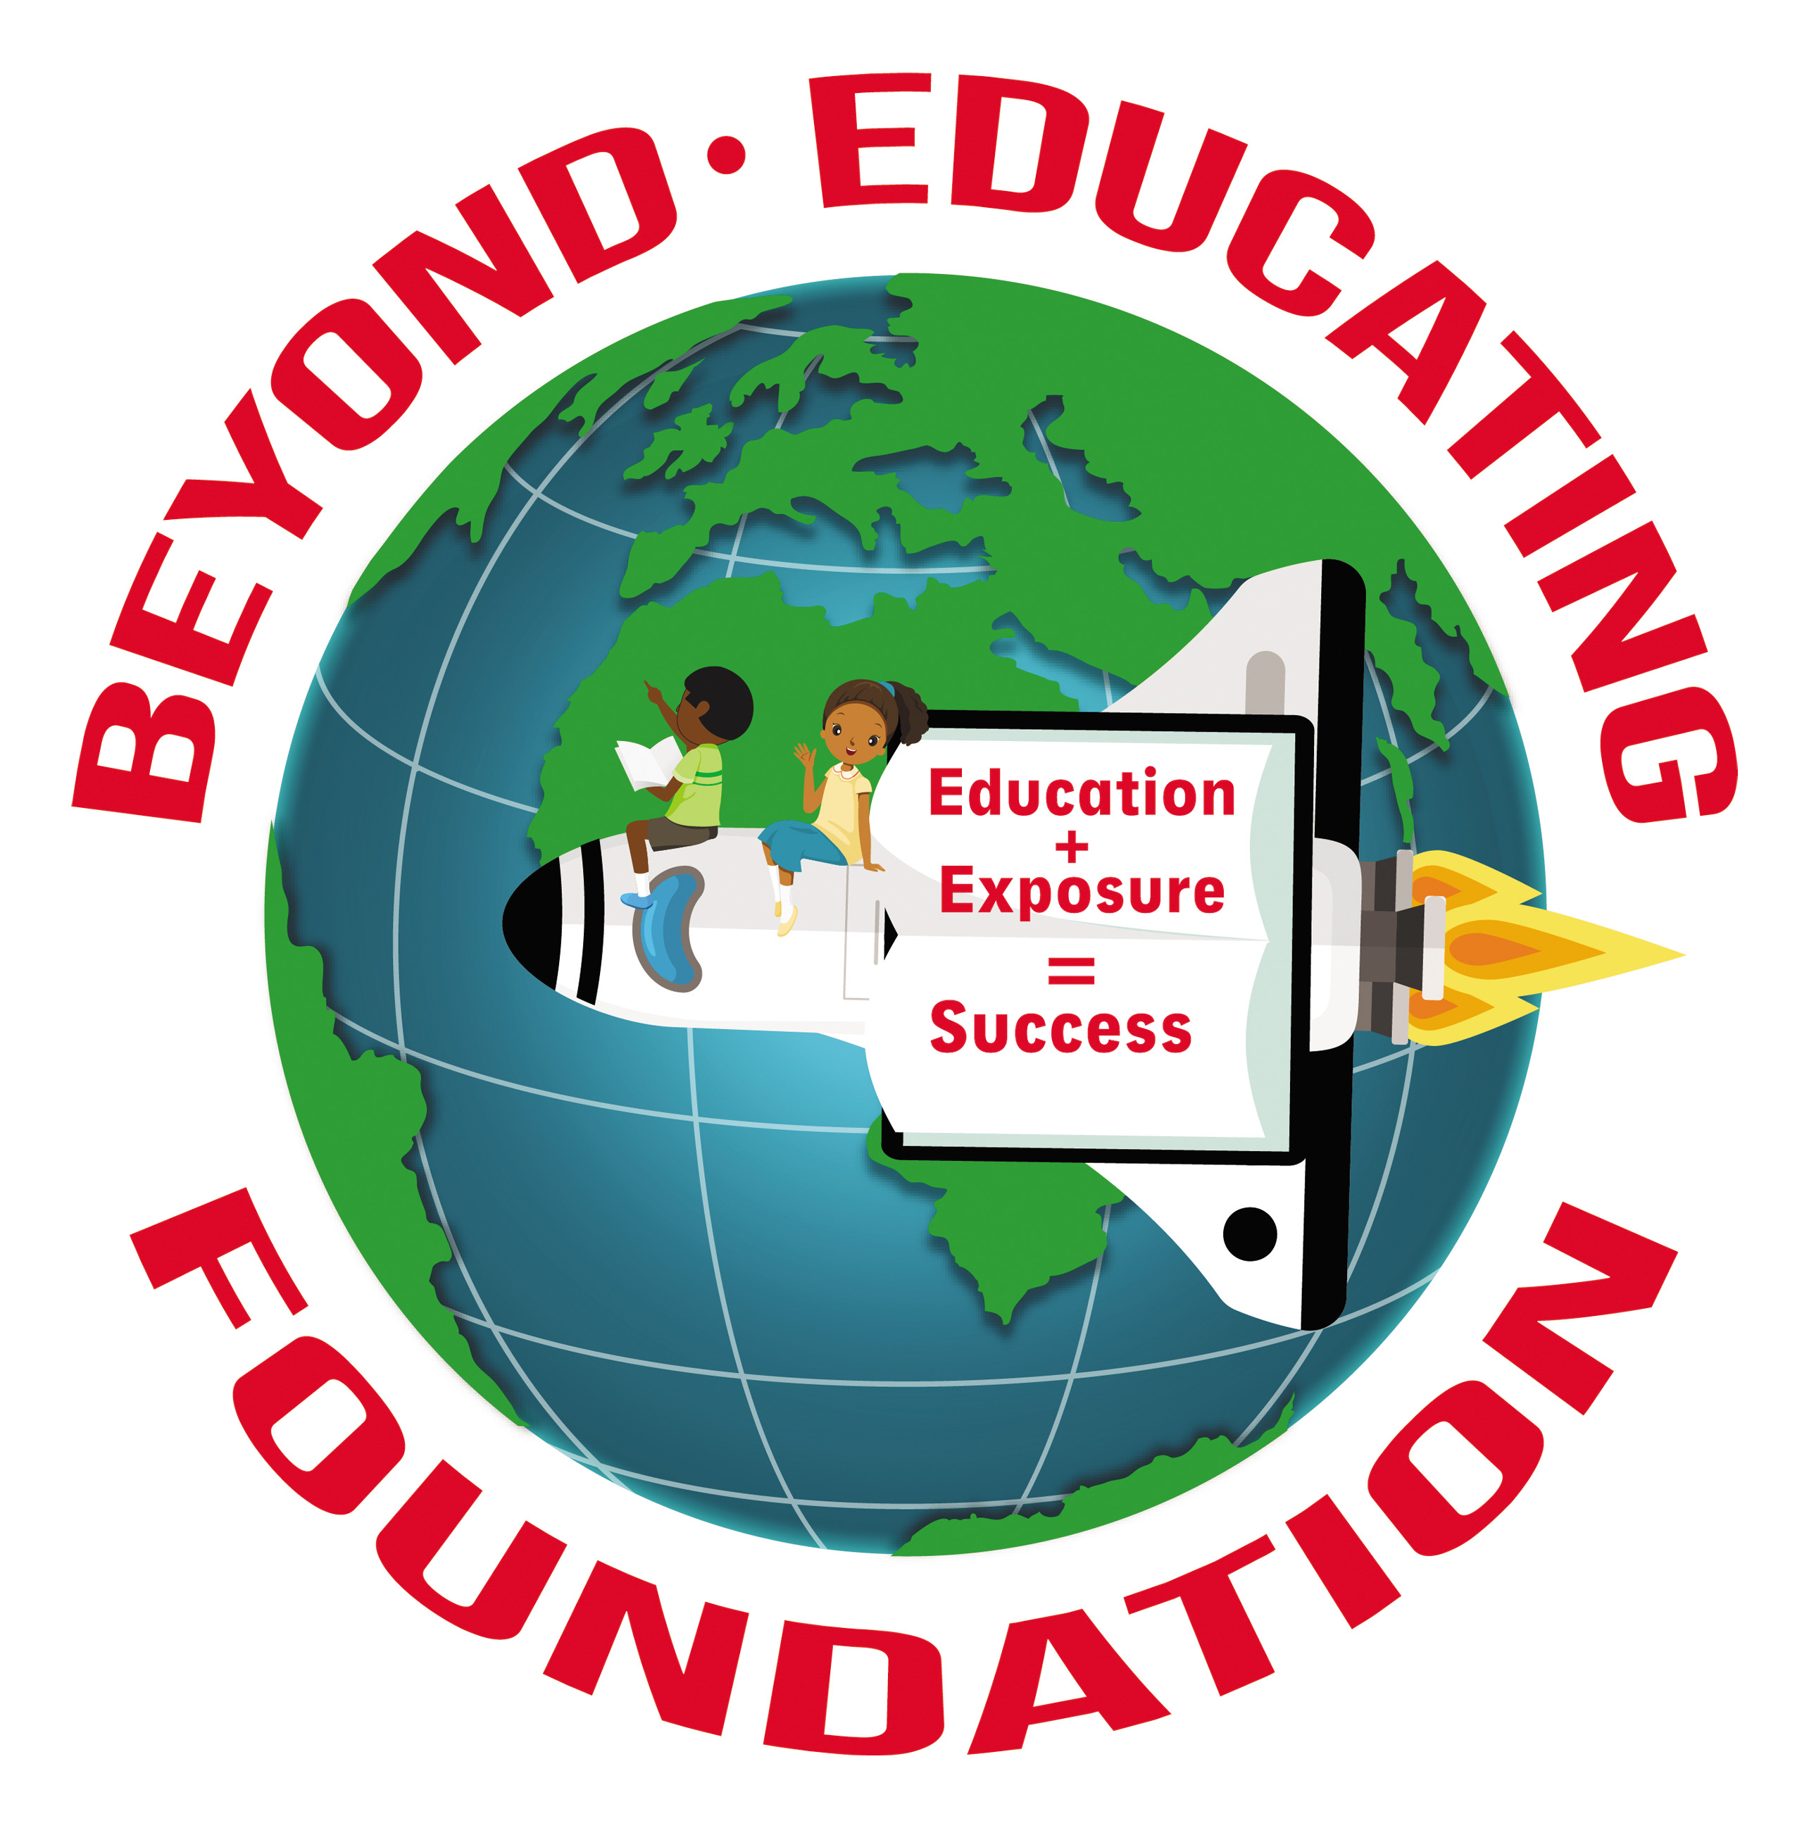
Beyond Educating Foundation
888-217-9797
cheers@beyondeducating.org
www.beyondeducating.org
Growth Mindset requires that people engage in the process of their own personal growth. It is natural to become overly attached to what we think works and to what is familiar. Beyond Educating Foundation is a 501c3 organization that wants to help underprivileged communities develop a growth mindset. Since, we are all capable of learning and experiencing, these two constructs can be easily fulfilled. Beyond Educating Foundation believes that educational exposure will help communities think big and act like creators and producers instead of just consumers. Communities with educational confidence don’t assume one "right way" to build and prosper but recognize that their unique way is the right way!
Beyond Educating Foundation would like to host Developing A Growth Mindset Through S.T.E.A.M. Toy Giveaway on December 7, 2019 at Gaston Community Center. The purpose of this toy giveaway will be to obtain contact information of citizen that live in the South Memphis area. Upon completing the membership application, each child within that family will receive a wrapped gift. While the adult family member is completing the membership application, children ranging from 5-16 years of age will be able to interact with volunteers to complete various S.T.E.A.M. activities. Once we have determined if they reside in our targeted zones, we will reach out to these families via phone call and mail. We will invite the family to a five series seminar about Developing a Growth Mindset Through S.T.E.A.M.

Beyond Educating Foundation
888-217-9797
cheers@beyondeducating.org
www.beyondeducating.org

Beyond Educating Foundation will host Developing A Growth Mindset Through S.T.E.A.M. Toy Giveaway on December 7, 2019 at the Gaston Community Center.
Purpose: to provide small demonstrations of STEAM Education, to obtain contact information of citizen that live in the South Memphis area so Beyond Education Foundation can provide their community members with an insight of their true potential
Once we have determined if the families reside in our targeted zones, we will reach out to these families via phone call and mail. We will invite the family to a five series seminar about Developing a Growth Mindset Through S.T.E.A.M.
Upon completing the membership application, each child within that family will receive a wrapped gift. While the adult family member is completing the membership application, children ranging from 5-15 years of age will be able to interact with volunteers to complete various S.T.E.A.M. activities.

If your company can assist with any of the following items:
- Volunteers
- Breakfast items for 40 people
- Lunch items for 40 people
- 20 STEAM LAB Kits
- 50 Girl Toys
- 50 Boy Toys
- Monetary Donation
- 20- $10 gift Cards
- Booth space is provided for your company to advertise your products/services.

In return your company will be listed and advertised as a sponsor for our educational, tax deductible, and non-profit organization.

Tax Id#: 83-1378159

Lastly, we thank you for your time and we hope to hear from you soon. Your consideration is appreciated.

Best if received by: November 25, 2019

Use the contact information above to contact Keauna Cheers, Executive Director, for more information and/or details.

Best Regards,
Beyond Educating Foundation

